2024 Parades
Rules & Regulations



BUCCANEER DAYS
PARADES
TABLE OF CONTENTS

General Information p. 3

Night Parade Route p. 4

Children’s Parade Route p. 5

General Rules p. 6

Rally Night Parade Special Rules p. 11

Children’s Parade Special Rules p. 12

BUCCANEER DAYS

May 2 – May 12, 2024

GENERAL INFORMATION

MISSION
The Buccaneer Commission is a philanthropic organization that hosts Buc Days, Rodeo Corpus Christi, and other events in the Coastal Bend. Its core mission is as follows:

Promoting tradition and community pride in the Coastal Bend by producing exceptional family entertainment that results in educational scholarships.
To date, the Buccaneer Commission has awarded over $1.8 million in scholarships and grants.

BUC DAYS SCHEDULE

Opening Night, Stripes Carnival Dollar Night Thursday, May 2
Dunking of the Mayor Thursday, May 2 at 6pm
Buccaneer Days Coronation Pageant Thursday, May 2
PBR VT Finals (Perf 1) Friday, May 3 at 7:30pm
PBR VT Finals (Perf 2) Saturday, May 4 at 7:30pm
Rally Night Parade Saturday, May 4 at 8pm
Division Youth Showcase- Rodeo Corpus Christi (Perf 1) Tuesday, May 7 at 7pm
Rodeo Corpus Christi (Perf 2) Wednesday, May 8 at 7pm
Rodeo Corpus Christi (Perf 3) Thursday, May 9 at 7pm
Rodeo Corpus Christi (Perf 4) Friday, May 10 at 7pm
Rodeo Corpus Christi (Perf 5) Saturday, May 11 at 7pm
Children’s Parade Saturday, May 11 at 10am
Stripes Carnival Closing Day Sunday, May 12

PARADE ENTRY TIMELINE

Applications Due to Buccaneer Commission Office (Online Only) Monday, April 1st

PARADE DEPARTMENT CONTACT INFORMATION

BUCCANEER COMMISSION
Elyse Suckley, Competitions and Marketing Coordinator
P.O. BOX 30404
Corpus Christi, TX 78463
Cell: 361.882.3242
Elyse@BucDays.com

RALLY NIGHT PARADE ROUTE
Route is subject to change

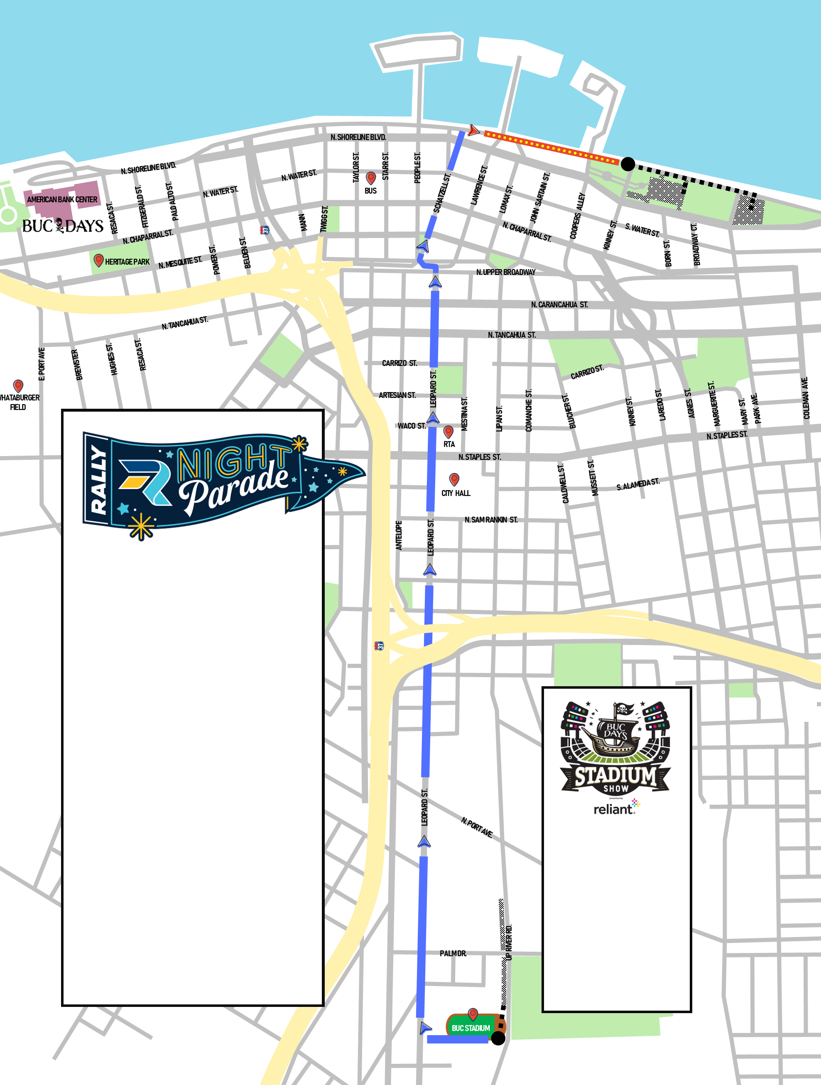

CHILDREN’S PARADE ROUTE
Route is subject to change

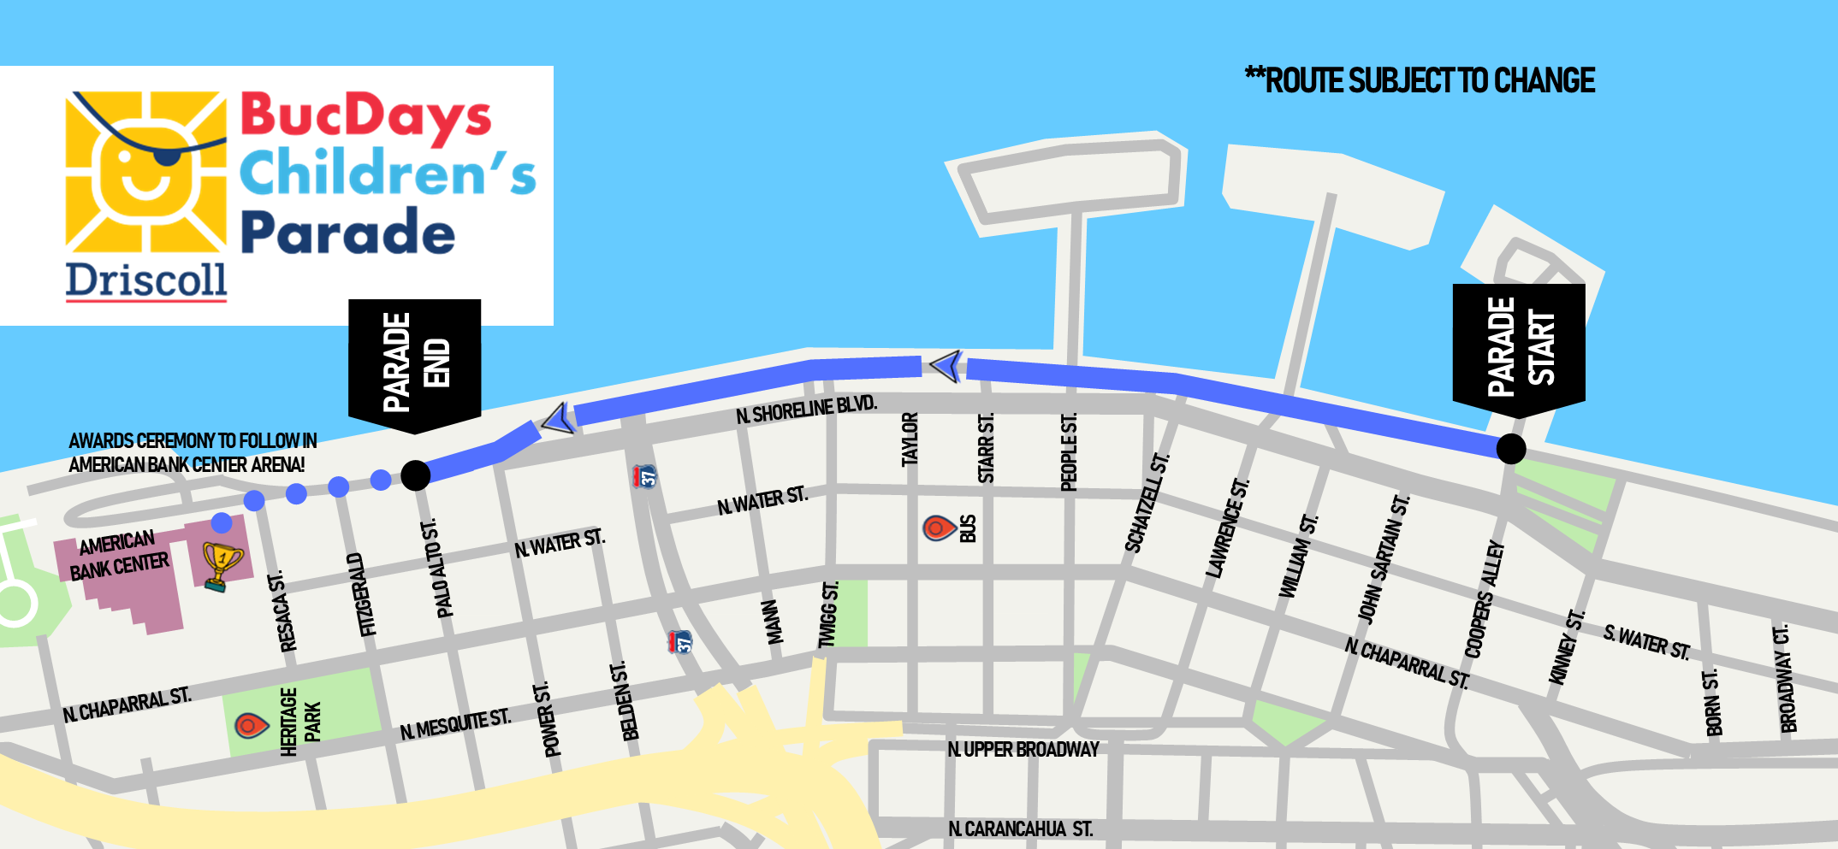

BUCCANEER DAYS

PARADE ENTRY
GENERAL RULES

The Buccaneer Commission has established rules for Parade Entries, hereinafter “Participant(s)”, to allow for a safe and fun environment for all Participants to experience. The rules and regulations provided are intended to ensure a level quality and safety for the public. To achieve success, everyone must understand and follow these rules and regulations.

- Interpretation and Violation of Rules: Buccaneer Commission Management reserves the final and absolute right to interpret these rules and settle and determine all matters, questions and differences in regard thereto or otherwise arising out of or connected with, or incident to, and to amend or add to these rules as its judgment may determine. Any Participant(s) who violates any of the rules will forfeit all privileges and be subject to such penalty as the Governing Board may order.

The Governing Board shall have the further right to delegate any or all of the rights, authorities and responsibilities which it has under these rules to such parade officials as it deems appropriate.

- Parade Superintendent: The Parade Superintendent has the authority to enforce the rules herein described. He or she will inspect parade entries during staging to be sure they comply with representations made in the applications. The Superintendent will be present during the parades to assist Parade Officials.

- Application: Parade applications may be obtained by visiting www.bucdays.com. All parade applications must be legible, completed in full, and accurately describe and depict your entry and any support personnel and vehicles on the parade route. All applicants (except Marching Bands) must submit a $25.00 non-refundable application processing fee. This means, if your group has a Float and an Equestrian unit, an additional $25.00 non-refundable application-processing fee is required for each. (See Multiple Groups). Check or money orders shall be made payable to the Buccaneer Commission, Inc. Applications will not be accepted without appropriate fees and must be postmarked by April 1, 2024. Incomplete and late applications will not be accepted. There will be no exceptions to the deadline date above and submission of the application does not guarantee acceptance in the parade. An application is considered complete when it is submitted with a signed application a photograph or drawing of the entry, any required insurance information, and all participants have signed the WAIVER. Notification of acceptance or non-acceptance will be sent via email. Completion of an application does not guarantee acceptance for participation in a parade. The Buccaneer Commission reserve the right to accept or deny any application and/or participant for any reason.

It is imperative to submit your application as early as possible; however, early submission does not guarantee parade acceptance. Acceptance to participate in the parade is determined by the Buccaneer Commission, Inc. Cause for non-acceptance of a parade entry does not have to be justified by the Buccaneer Commission, Inc.

Entry Fees: Night Parade
Commercial: $500
Non-Profit: $25
Bands: Free

Children’s Parade (Participants under 15 years of age)
Commercial: $100
Non-Profit: Free
Bands: Free

All non-profit entries that request exemption from Commercial/Corporate fee must submit written proof of non-profit status from the IRS to the Buccaneer Commission, Inc. with their application.

Entries that do not provide proof of their non-profit status must pay a Commercial/Corporate fee. These fees must be received with the application no later than April 1, 2024.

- Types of Entries: There are multiple ways to participate in the Buc Days Parades. The following are the different types of entries available:

Float: A float is a highly decorated and illuminated exhibit (Lighting Only Required for Night Parade) or scene mounted on a mobile platform or trailer and pulled or driven in the parade.

Bands: A group in which instrumental musicians perform marching down the parade route.

Miscellaneous: Any unit other than bands or floats that may consist of marchers, drill teams, athletic groups, horse units, motor clubs, etc. Motorcycle clubs are restricted to a maximum of 10 motorcycles per club. Car Clubs are restricted to a maximum of 6 cars per club.

- Multi Groups: All multiple groups are required to submit additional application and $25.00 non-refundable application processing fee. For example, if your group has a Float, a Marching unit, and an Equestrian unit, 3 applications and (3) $25.00 non-refundable application processing fees are required.

- Unit Description: A detailed description of the entry including a photo or drawing is required of each entry and must be submitted with the application.

- Statement of Non-Discrimination: In the selection of entries by the Buccaneer Commission, Inc., there shall be no discrimination based on race, color, religion (creed), gender, gender expression, age, national origin (ancestry), political views, disability, marital status, sexual orientation, or military status.

- Participation: Buc Days Parades are pirate themed parades and the Buccaneer Commission reserves the right to refuse entry to any participant who does not comply with any of our requirements. All participants are expected to behave in an exemplary manner. Any rudeness, foul language or threatening behavior will be grounds for the removal of any individual and their group from the parade. There will be absolutely no consumption of alcoholic beverages by any participants in the staging area or along the parade route. It is prohibited to remove, discard or make available to anyone along the parade route any lights, parade props, medals or other miscellaneous items. Failure of participants and their support personnel to comply with these Parade Policies and Guidelines will not be tolerated. This will result in removal from the parade by Parade Officials and/or Corpus Christi Police Department and will jeopardize future participation.

In addition, entries on parade day must appear as a fair and accurate representation of what had been submitted on the application. Any deviation without the authorization of the Buccaneer Commission, Inc. will result in disqualification on parade day. For the Night Parade, all participants must be 12 years of age or over in good physical condition. Due to safety and liability, no participants under 12 years of age will be permitted except on a float and must be noted on the application. Any floats with children under the age of 12 must be supervised at all times and the person supervising must be part of the respective organization and entry. Participants on floats under the age of 12 must have parent and/or guardian sign the WAIVER. This form must be turned in with the application no later than April 1, 2024.

- Television Coverage: The Parades may be televised locally. TV Script/Media information must be completed in the application and submitted in the application no later than April 1, 2024, in order for the television host to describe your entry. No parade entry will be allowed to intentionally stop and perform. Violation of this policy will result in a disqualification of the organization from the judging. At the discretion of the Parade Officials, violators may be removed from the parade route and eliminated from participation in future parades.

- Safety: All entries must be operated in a legal, safe, and ethical manner and comply with law enforcement and Bucarader directions. Any lewd behavior or profane music will not be tolerated and will be grounds for removal from the parade and expulsion from future parades. The consumption of drugs, tobacco or alcohol by all parade participants is strictly prohibited.

- Offensive Items: Buccaneer Commission Management reserves the right to prohibit the display of any item that Buccaneer Commission Management reasonably deems objectionable from the standpoint of taste, quality or compatibility with the Buccaneer Commission’s mission. Some items that will be considered offensive include but are not limited to: weapons of any kind, lasers, high powered water guns, rubber band guns, toy guns, unsafe, obscene, pornographic, drug related items, controversial items or displays, or any item that may be considered political in nature. Controversial is defined as something that “gives rise or is likely to give rise to public disagreement.

- Political campaign activity/electioneering: As the Buccaneer Commission is a 501(c)(3) organization, no political campaign may post signage or use the parade for or against candidates for elected office. Any signage related to a political campaign or issue is strictly prohibited.

- Music and PA: All entries with live music or sound enhancement systems must include the information on the application. Sound amplification must comply with the City of Corpus Christi Ordinance. The audio level will be set at a reasonable level as determined by the Parade Officials.

- Advertising: Advertising or promotion for commercial purposes is prohibited on or with any parade unit unless a commercial entry fee has been paid. Commercial entries may only display the name of the business/organization submitted on the original entry form. Additional signage, logos, banners, truck decals, etc. identifying any other business/organization will require an additional commercial entry fee to be paid or the signage must be covered before allowed on the parade route. Certain commercial entries maybe refused due to conflicting sponsor relationships with the Buccaneer Commission.

- Marcher Requirements: Anyone that chooses to walk the parade route must be at least 14 years of age (Night Parade Only) and at least 4 years of age (Children’s Parade Only). Anyone walking, must remain with their unit in their assigned position in the staging area and proceed in a steady and continuous manner during the parade. Bands are allowed to bring a small chase vehicle carrying water and other necessities in the parade.

- Float Requirements: Each float must be highly decorated, including tow vehicles; have flame-retardant decorations or other materials; and a working and easily accessible fire extinguisher. No entry may exceed 45’ in length 13’6” in height.

All Float decorative material shall be noncombustible or flame retardant. The use of hay as decoration or prop is not permitted. Floats and towing apparatus shall be provided with a minimum 2-A 10-B:C or higher rating portable fire extinguisher readily accessible to the operator with a valid current (within a year) inspection sticker from a licensed extinguisher company or provide proof that extinguisher is new (store receipt). The fire extinguisher will be inspected by Parade Officials.

- Equestrian Units: Only professional Equestrian units will be permitted in the parade. The unit must provide a list of parades they have participated in during the past year. These units must provide a “pooper scooper” to follow the entry and ensure no fecal matter is left on parade route.

- Parade Pace: All parade entries must stay within their allocated space in the staging area. At the start, Parade Officials will space out the entries at approximately every twenty-five (25) feet and entries should maintain that distance throughout the parade route. Parade Officials will strictly monitor this spacing. While on the parade route, all entries must maintain a constant forward direction. Unnecessary delay or “gaps” created by the entries on the parade route will not be tolerated and may be subject to removal. Participants may not slow or stop the forward movement of the parade in any way. Entries that stop to perform along the parade route will be disqualified from the judging and eliminated from participation in future parades. At the discretion of the Parade Officials and CCPD, any entries unable to start or maintain their assigned position on the parade route will be removed.

- Towed Entries: All towed entries must have approved safety chain between the tow vehicle and unit/float. All tow units shall be securely fastened with appropriate safety chains to the chassis of the float. No sleeper trucks or set forward axle trucks are permitted in the parade as there is inadequate turning space for these types of vehicles. Please contact the Parade Coordinator if you have questions about the types of tow vehicles that are acceptable.

- Generators: Generators must have sufficient fuel to operate. Generators should not be started until the parade begins to preserve fuel. Adding fuel to hot generators is strictly prohibited.

- Accessibility: All floats and miscellaneous entries must have easily accessible entrance and exit for participants and a clear unobstructed view for the driver/operators.

- Drivers: Drivers/Operators of any unit must be 21 years of age or older, have a valid driver’s license suitable for operation of the type of vehicle and current proof of insurance. Should the driver not be able to provide proof of insurance and a valid driver’s license at the staging area, the unit will not be allowed to proceed down the route.

- Prohibited Items: Buccaneer Commission Management reserves the right to prohibit the display of any item that Buccaneer Commission Management reasonably deems objectionable from the standpoint of taste, quality or compatibility with the Buccaneer Commission’s mission. Some prohibited items include but are not limited to: weapons of any kind, lasers, high powered water guns, rubber band guns, toy guns, unsafe, obscene, pornographic, drug related items, controversial items or displays, or any item that may be considered political in nature. Controversial is defined as something that “gives rise or is likely to give rise to public disagreement.

- Throwing or Distribution of Items: It is prohibited for parade participants to throw, distribute, or give away any leaflets, coins, souvenirs, candy, or any other items in the staging area and on the parade route. No articles, materials, or candy of any kind shall be distributed in the staging area, along the parade route or in the disbanding area without the approval of the Buccaneer Commission, Inc. The discharging of firearms, cannons, fireworks, and other loud devices is strictly prohibited.

- Break-up: All parade participants will disband under the direction of the Parade Officials. No participants should remove any illumination devices, costumes, or uniforms until they have reached their designated area. It is prohibited to remove, throw away, discard or make available to anyone along the parade route or disbanding area any lights, medals and parade props. Parade participants may not leave the Float prior to reaching the disbanding area.

- Inclement Weather: Be prepared, the Parade will go on rain or shine. If inclement weather occurs prior or during the parade, Corpus Christi Police Department will determine if reports of severe weather shall initiate the cancellation or delay of the parade. Participants may decline to participate when weather threatens to damage uniforms, props, instruments, etc. We suggest that your organization have a weather plan in place should severe weather occur. Every effort will be made to ensure the safety of all participants. However, participants must understand the Buccaneer Commission, Inc. will not be held responsible for events beyond our control such as weather, civil turmoil, bomb threats and natural disasters. (No fees will be refunded). This includes participant property.

- Emergency Plan: In the event of an emergency, the Corpus Christi Police Department will determine if the parade will be delayed or cancelled. If the determination is made that the parade route needs to be evacuated for safety purposes, all participants will be directed to pre-identified safe zones by police officers. Only participants that are on foot and in vehicles other than floats will be directed to the safe zones. All floats will need to remain on the route; therefore, the drivers of the floats will stop their float as far right as possible and will leave the key in the vehicle. Float drivers and riders will need to dismount their float and will need to walk to the safe zone. Once the critical incident is resolved, coordination will be made to remove the floats from the route.

- Stadium Show Participant Requirements: All trailers that are 20ft or longer AND/OR being pulled by a vehicle/ truck that is larger than 1 ton will NOT be able to drive through the stadium. Any vehicle that we deem might cause damage to the track i.e. low rider vehicles, fire trucks, tow trucks, etc. may be asked to not participate in the stadium portion of the show.

RALLY NIGHT PARADE
May 4, 2024
Special Rules

- Theme: Participants are encouraged to wear uniforms and costumes and decorate their entries to support the pirate theme of the parade.

- Illumination Requirement: All entries and bands must also use a creative form of illumination to enhance their appearance. If an entry has no illumination, the consequence could be removal from the parade. The illumination enhancement will be crucial not only to the judging category, but part of the Buc Days Rally Night Parade requirements. Battery operated LED mini-lights are an excellent form of illumination. A minimum of twelve (12) mini-lights per person is recommended. The Buccaneer Commission, Inc. recommends this form of lighting. All entry banners should also be illuminated when possible.

- Judging and Awards: Judging of Bands will take place along the parade route. Therefore, Band participants should perform at their best during the entire parade route. Floats and Miscellaneous Units will be judged in the staging areas. Awards will be presented on the route as appropriate.

- Complete paper entry form below or enter at bucdays.com no later than April 1, 2024.

CHILDREN’S PARADE
May 11, 2024
Special Rules

- Theme: Participants are encouraged to wear uniforms and costumes and decorate their entries to support the pirate theme of the parade.

- Children’s Parade: The Children’s Parade is limited to participants under 15 years of age with the exception of sponsors and chaperones.

- Judging and Awards: Judging of bands will take place along the parade route. Therefore, Band participants should perform at their best during the entire parade route. Floats and Miscellaneous Units will be judged in the staging areas. Awards will be presented in the American Bank Center Arena immediately following the parade.

- Complete paper entry form below or enter at bucdays.com no later than April 1, 2024.

